**Module 10 – Single Page Application framework – React**

**15.ReactJS-HOL**

**1. Explain about React Forms**

In React, forms are used to capture user input — just like in regular HTML. But in React, we handle form data using **state** so that the input values are always in sync with the component. This makes form handling more powerful and interactive.

**2. Define Controlled Components**

A controlled component is an input element (like <input>, <textarea>, etc.) whose value is controlled by React using state. This means the input value is stored in a state variable, and updated using onChange.

Example:

const [name, setName] = useState('');

<input type="text" value={name} onChange={(e) => setName(e.target.value)} />

**3. Explain about Various Input Controls**

React supports all standard HTML input controls, such as:

* Textbox (<input type="text">) – for short inputs like names, emails.
* Textarea (<textarea>) – for long inputs like descriptions or messages.
* Button (<button>) – for submitting forms or triggering actions.
* Others: Radio buttons, checkboxes, dropdowns, etc.

**4. Explain about Handling Forms**

To handle forms in React:

* Maintain form data using state variables.
* Use onChange to update state whenever the user types or changes input.
* Use onSubmit or a button click to process the form.

**5. Explain about Submitting Forms**

When a user submits the form:

* We usually handle it using a function like handleSubmit.
* Inside this function, we can validate, process, or send the data.
* In this lab, you'll also generate a reference number and show it using alert().

**Structure:**

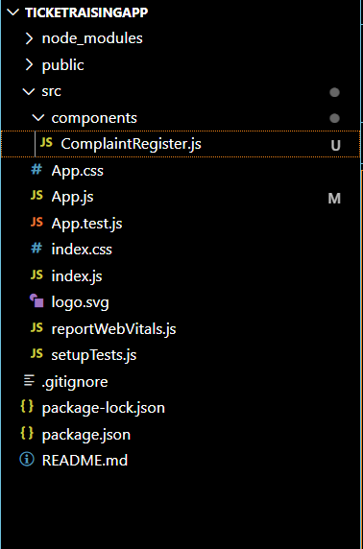

**ComplaintRegister.js:**

import React, { useState } from 'react';

function ComplaintRegister() {

  const [name, setName] = useState('');

  const [complaint, setComplaint] = useState('');

  const handleSubmit = (e) => {

    e.preventDefault();

    const transactionId = Math.floor(Math.random() * 1000); // 3-digit random ID

    alert(`Thanks ${name}\nYour Complaint was Submitted.\nTransaction ID is: ${transactionId}`);

    // Clear form

    setName('');

    setComplaint('');

  };

  return (

    <div style={{ textAlign: 'center', marginTop: '50px' }}>

      <h2 style={{ color: 'red' }}>Register your complaints here!!!</h2>

      <form onSubmit={handleSubmit}>

        <div>

          <label>Name: </label>

          <input

            type="text"

            value={name}

            onChange={(e) => setName(e.target.value)}

            required

          />

        </div>

        <br />

        <div>

          <label>Complaint: </label>

          <textarea

            value={complaint}

            onChange={(e) => setComplaint(e.target.value)}

            rows={3}

            cols={30}

            required

          />

        </div>

        <br />

        <button type="submit">Submit</button>

      </form>

    </div>

  );

}

export default ComplaintRegister;

**App.js:**

import React from 'react';

import ComplaintRegister from './components/ComplaintRegister';

function App() {

  return (

    <div>

      <ComplaintRegister />

    </div>

  );

}

export default App;

**Output:**

